How to guide:
Content Management System (CMS)
www.moonstone.co.za/media
Username:
Password:

Index:
- Moonstone website Structure pg 2
- How to do basic tasks on the CMS:
- 1. Publishing a Post: (Moonstone Online – articles) pg 3
- 2. Uploading a new document onto the website: pg 7

Structure: Moonstone.co.za
- Page: Moonstone – online
- Posts (online news)
- Advertising
- Sidebar: (Twitter feed, Carreers feed, Advisor Store link, Latest post feed,Protector Service ad)
- Sevices:
- Page: Regulatory Exams
  - Main page (service copy + hyperlinks(exam schedules etc)
  - Filebase: FSB library
  - Filebase: Examination library
  - Registration link to external registration website (faisexam.co.za)
- Page: Moonstone Compliance
  - Main page (service copy + hyperlinks)
  - Filebase: FSB library
  - Filebase: Moonstone library
  - Sidebar: Borchure download (Comprehensice Services)
  - Sidebar: Protector service link (external)
  - Contact Forms: Compliance Enquiry Form (sidebar)
- Page: Moonstone Licensing
  - Main page (service copy + hyperlinks)
  - Filebase: Moonstone library
  - Sidebar: Borchure download
- Page: Moonstone Training: Skills & Qualifications
  - Main page (service copy + hyperlinks)
  - Sidebar: Borchure download
- Page: Moonstone Formation Refinery (Pty) Ltd
  - Main page (service copy + hyperlinks)
  - Sidebar – hyperlinks to external Rates x2
  - Link to advisor store
  - Filebase: Moonstone library
- Page: Careers
- Page: Advisor Store (Books & DVD’s)
- Page: CO Desk
- Blog post
- Q & A
- Knowledgebase

How to do basic tasks on the CMS:
- Publishing a Post: (Moonstone Online – articles)
To be uploaded on same day as publication (Mondays, II and Thursdays, Monitor) – a slight delay can be scheduled for the articles to only be available by 16H30 on the day.
- On the dasboard select “Posts”
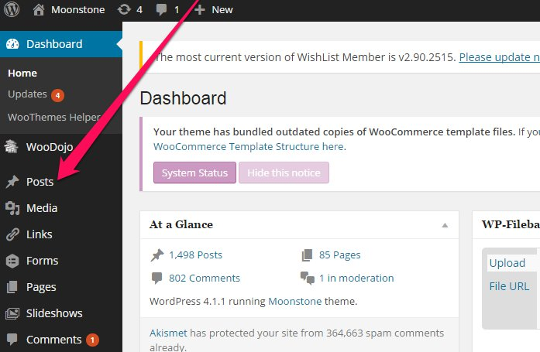
- Select “Add New”
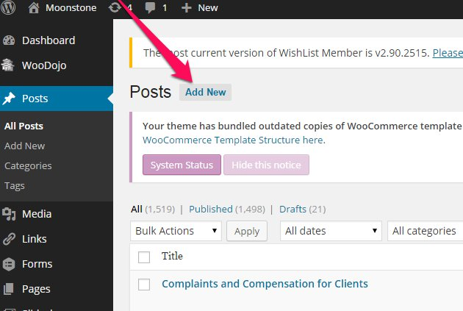

- Copy the article, paste into post & enter the title.
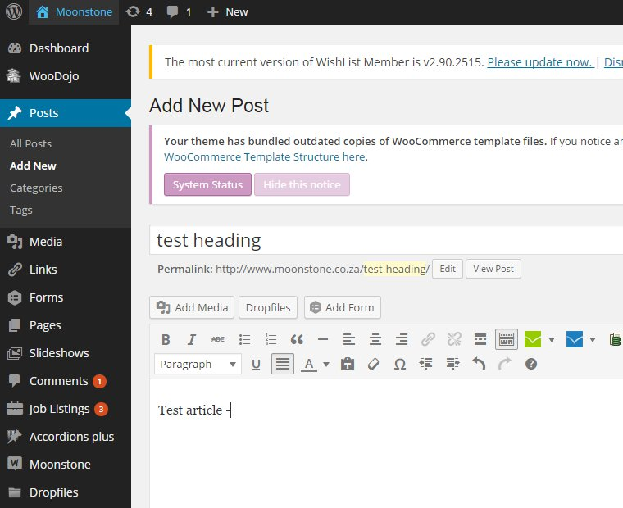

- Categorize the article ( depending on the particular topic) – you will note the Categories on the right sidebar on the same page as the “New Post” page
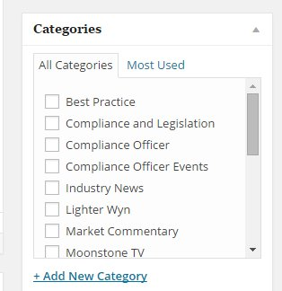
NB: Make sure text all same size/format/colour
‘Preview’ the article before pressing ‘publish’
e) Content Protection
Select “Yes” option at Content Protection for CO Desk posts only
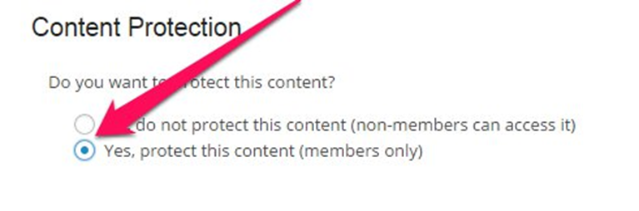

- Once published - change “Author” 1 & Add Tags relevant to article 2 and update 3.

Go to - All Posts page – select quick edit function on the relevant post (hower over article title and “Edit Quick Edit Trash” View menu will apear – see below)
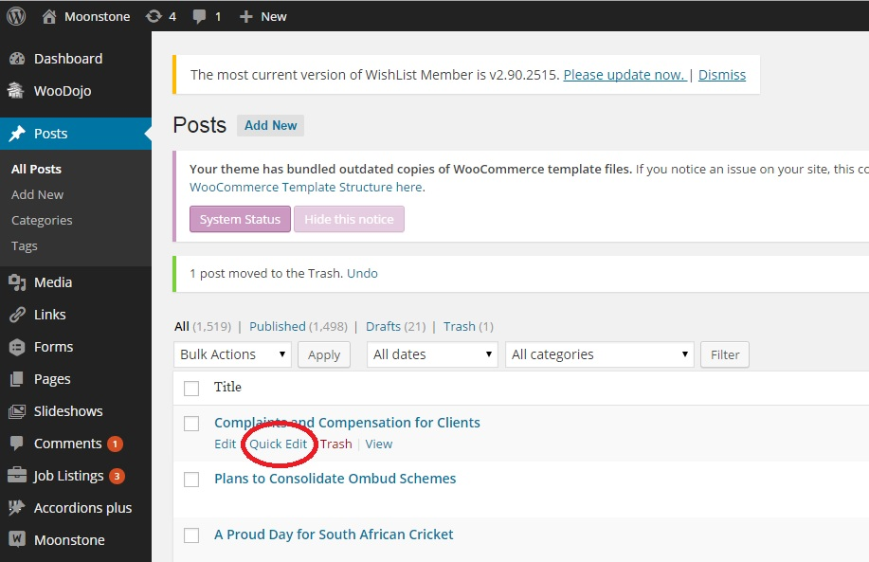
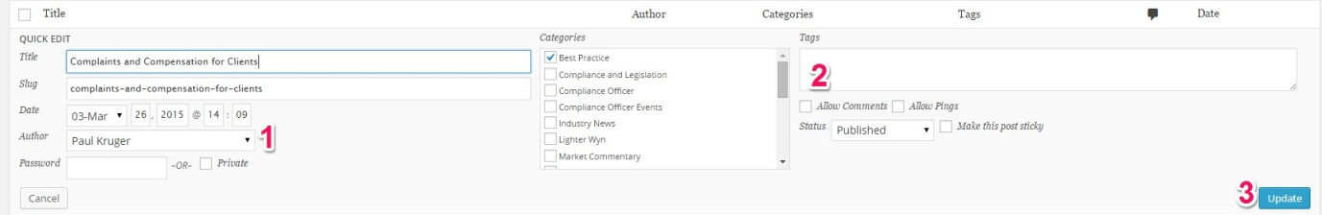

- Featured image: Set Display Image (Size 610x220)
- Use new pictures, not the old MS Word Graphics – Select “Add media” select featured image.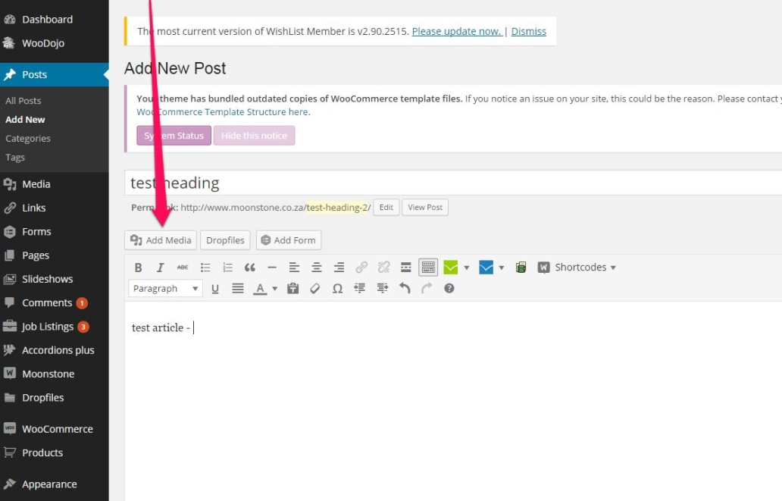
Select “Upload Files” – Select Files (once uploaded) – select as Featured image
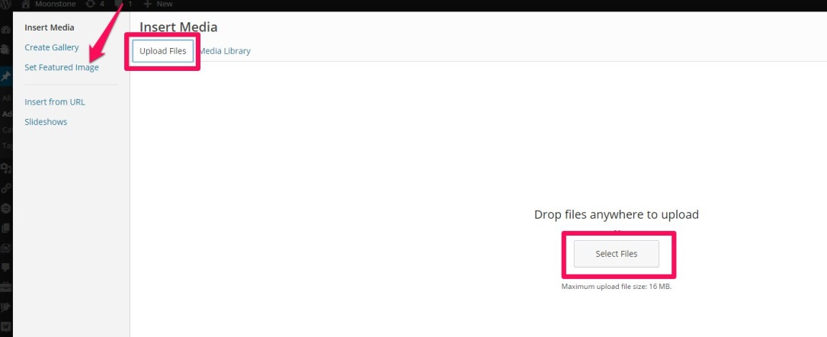
- Selecting a article link
Once a article has been published - select “edit post” on “all post” menu – select “get shortlink” and copy & paste link A.

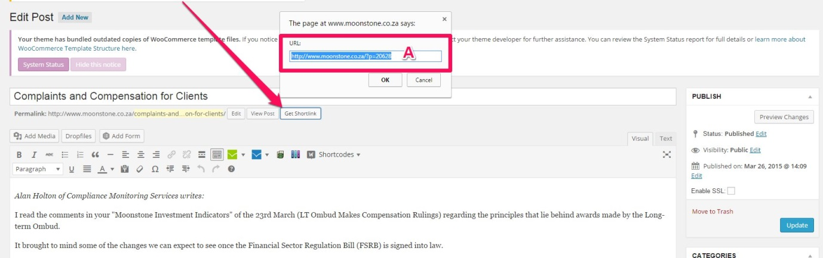

- Uploading a new document onto the website:
Plugin: Filebase Pro
- Save Document as PDF on Website uploads –
public drive: marketing/webstite/website uploads/ (Use format: moonstone-*****.pdf)
- At Moonstone Dashboard:
  - Select: WP Filebase Pro – plugin is located at the bottom of the navigation bar on the left. A

  - Select: Files B
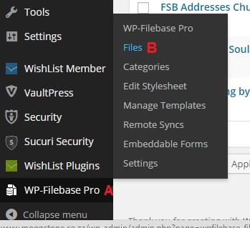
  - Select “add new”
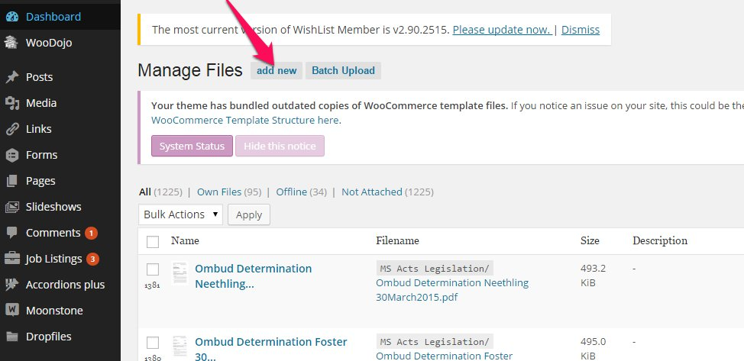

  - Choose File (Browse function will apear)
  - Complete requested details – title, version(date), author, date & description
  - Select relevant Category for the file
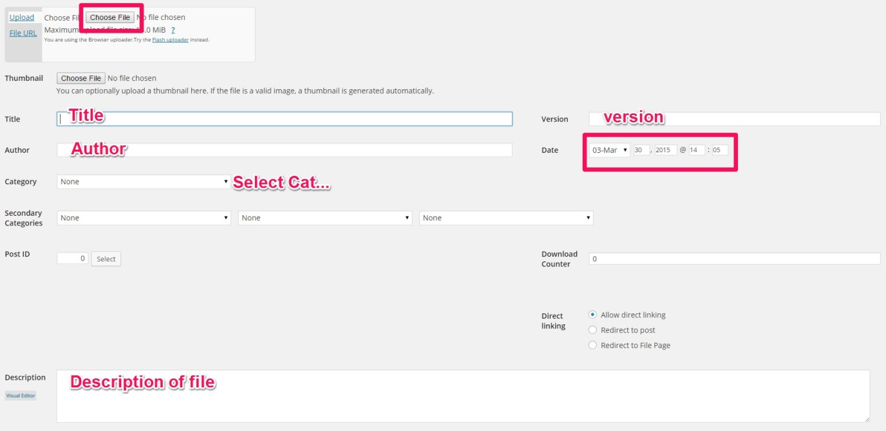
  - Add File
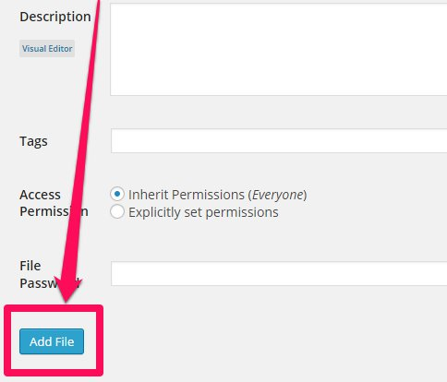

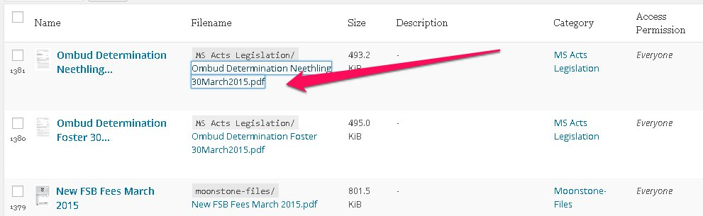

- Right click on the filename. Copy Link address

- Send link to whoever wanted the file to be uploaded.

Job listing – Careers platform
- 2 Options
- Featured option (ad appears on website & e-newsletter)
- Website option ( ad appears on website only)
- At joblisting, on dashboard, review ad for mistakes (Listing will display under “Pending Payment” tab)
- Change the “author” to the clients name, update their profile picture and add “about us” of the company. (You will edit this under “users” not job listings)
- Send email to client, saying that you received the submission and the ad will be active once payment is received.
- Wait for payment to be made (follow up when payment is not received in time period)
- Go to Woocommerce, find listing and “tick” once payment is received.
- Activate ad.
Careers platform ad in Monitor en II
- Public/Marketing/Website/Career Platform/Newsletter Copy
- Open previous document
- Check if all jobs listed is active.
- Get Anton to take off old listings (by changing them to red) and add new listings (change to yellow)
- Change footer to ms-dk/date?
- Send document to anton van rooyen every Monday/Thursday mornings before 10am.

Social Media
- Try to post all articles on all social media platforms throughout the week. (Twitter, Linkedin, Twitter automatically posts on facebook as well)
- Join LinkedIn groups on which you can post articles that Paul writes

Queries received via website
- Licensing - Abigail Sampson ASampson@moonstoneinfo.com
- Training / long term / short term FAIS accrdiatation etc - Ronel Nell ronel@moonstoneinfo.com
- Examiniations – Fais Exam
- Newsletters – don’t forward as Anton v Rooyen receieved these
- Marketing ( eg, workshops/study material/DVD/courses/ ) – us
Moonstone people
- Make sure Moonstone collegues are always updated with their profile pic on the ‘my contact page’ on the website – contact Schalk with updated picture information and stipulate the department in which they work in.

Events Page (when setting up a Workshop eg.)
- When creating an event (workshop) call upon Schalk
- Make sure you have all details
    - Event Name
    - Venue and address
    - Start and end date of registration
    - Start and end time of event
    - The presenters
    - What you will be charging each induvidual ( excl VAT)
    - Attendees limit
    - Refer to ‘Workshops’ folder in Public/Marketing for examples on how the invite looks
- To manage events:
    - Wordpress / MS Events / Event overview and click on the specific event
    - There are various actions on the right hand side, which can be chosen from in order to control ( View/ edit/ delete/ attendees and Export to an excel speradsheet)
    - 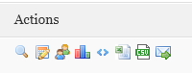
- To manage payment:
    - Proof of Payment is asked for as the client books and pays
    - Client receives an invoice upon booking via our events page on the web
    - POP is sent to the email address stipulated through an email as an attachment along with the booking and invoice form
    - Once received, go back into the event and click on the induvidual.
    - Go to payment options and after checking the person paid the correct amount into the correct bank account, change his payment status to ‘Complete’
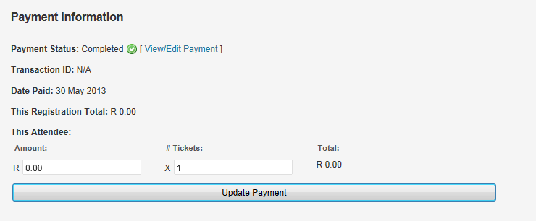
    - Reconcile towards the end of the registration date with Tracy in finance
    - She will print out a list showing all persons who have paid the specific amounts
    - Go into each person within the event and click on complete.
    - Contact those induviduals who have not paid 5 days prior to event.

Updating exam schedules
- Apon recieving update from Filansia
- Save doc in Website uploads, RE updates
- Then go to Moonstone Dashboard
- MS Filebase
- Files
- ‘Search’ ‘Moonstone Examination Dates - 2014’ in the search tab or for Afrikaans ‘ AFRIKAANSE EKSAMEN’
- Replace file by clicking on the ‘Browse’ tab
- Remember to always press ‘ Update’ at the bottom!
- Go to Pages and select “Regulatory Exam” page.
- Update hyperlink with new link to the updated file

Mail Chimp

- Use this mail system, before, during and after the event
- Before – is used to get the attention and detect approx. interest of attendees per event.
- Steps:

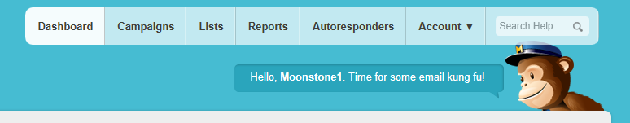
    - Campaigns – you can either build a new campaign or replicate one my choosing’ My Templates’ depending on the function you want to perform
    - Or replicate straight from campaign
    - Refer to my templates and previous campaigns done in the past.
    - Create a list by adding email addresses (export via excel ) is the easiest
    - Always send a ‘test’ to your email address before sending it out

Survey Monkey (when wanting feedback or conducting a random survey)

- Use the templates that have been conducted in the past:
- Go into ‘Create Survey’
- Either create and new one / or copy an exsisting one ( depending on your function)
- 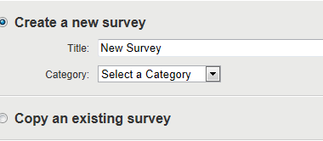
- Title and categorize the survey
- Discuss new questions with bobby and once decided then create new survey
- If using existing one, make sure all questions are relevant otherwise ‘edit’ each question.
- Always send a test survey, and always Preview the survey before sending it out
- After designing and sending out survey – monitor it / collect repsponses and analyse results
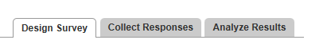

Creating Monthly Report

Login to http://www.google.com/analytics/index.html
Username: pkruger@moonstoneinfo.com
Password: moonstoneinfo
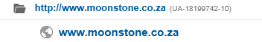
All previous reports are saved in Public/ Marketing / Management reports / 2014
The excel stats are saved in the Data graphs.xlsx
Follow the Index steps and work through these on new month ( copy and paste from previous months)
INDEX:
1: Website
a. Absolute Unique Visitors (AUV)
b. Traffic Sources
c. ‘Contact Us’ webpage stats
2: Campaigns / Events / Brochures
3: Blog
4: Social Media
5: Newsletters
6: DVD’s
TO START:
Choose your month and press apply:
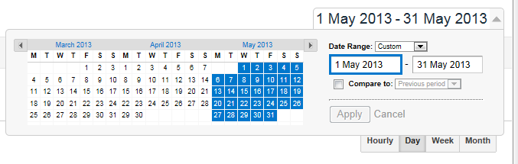
A: Find Unique visitors and place amount in the excel spread sheet – ‘ Visits for Website’

b. Traffic Sources are also done by clicking on Traffic sources / overview and then refer to the pie chart which is displayed
- Complete information on the Traffic Sources excel sheet then copy and paste chart into the Full REPORT
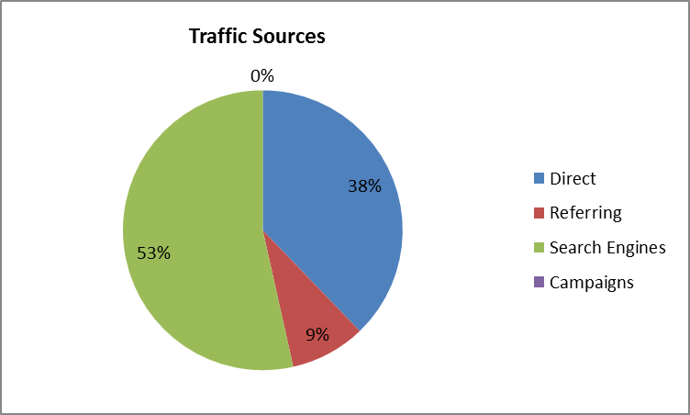
- Also record top referrals and keywords which is displayed
The 1c: Moonstone ‘’Contact us’’ Webpage statistics – is done via the MS Dashbord
- Select MS Design then select a form - Choose contact Page – Sept 2012
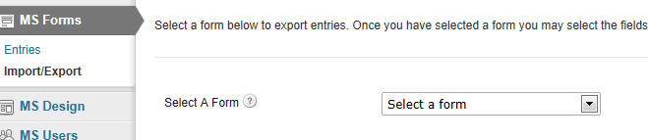

- Select ‘Please select the relevant department’
- Capture correct date range( start and End)
- ‘ Download Export File’
- Export and sort colum A by selecing A-Z
- Count each relevant department and capture in Excel spread sheet in Marketing/ Management reports and Stats ( ‘ Contact us’ graph)
- Copy and paste graph in month ‘Full Report’
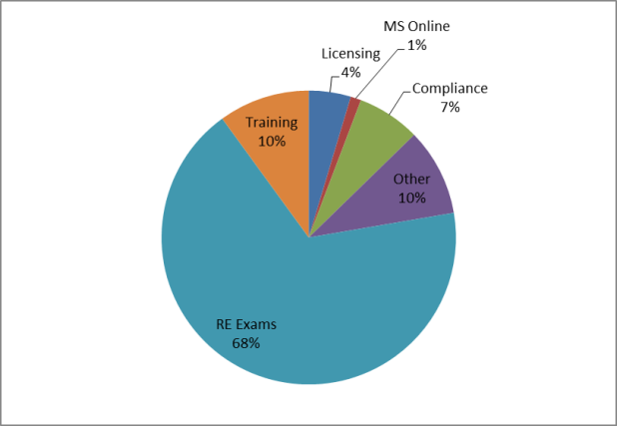
3: Moonstone Blog: ‘Pauls se Perspektief ‘

- Is done via Dashboard
- Select ‘ all posts’ on left hand side
- Use the Show all dates and choose month. Then Filter by selecting Pauls Perspektief
- Capture names of blog entries
- Then go to google analytics
- Content / Site Content / Overiview and All pages
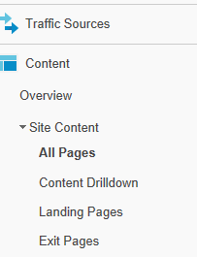

- Capture Unique Page views per entry
- Calculate Ave Monthly Blog visits by dividing the total visits by the number of entries
- Capture this on the BLOG ENTRIESExcel Stats sheet and copy into the full report
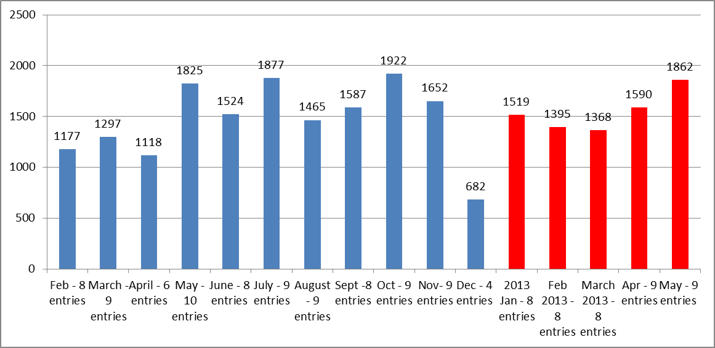
4: Moonstone Social Media -
- Captured by login into each media account – stats are shown on webpage
5a: Moonstone Newsletters
- Request form Anton – at end month
5b: Newsletter Advertisements
- Media Marx Stats are sent by Michelle
- Total earning for newsletter stats are received by Tracy van Heerden on a monthly basis
6: Moonstone DVD Orders
- Received by Tracy van Heerden on monthly basis
- Capture on excel spread sheet and copy new graph into Full report

NB Make a summary report by taking the details from FULL report.
May - M & C - Summary Report
Points and stats to capture on Summary:
1: Website
2: Blog
3: Social Media
4: Newsletters
5: DVD’s

